Where did the Iroquois people live?


The Iroquois people or Haudenosaunee lived in the Eastern Woodlands of New York. The Eastern Woodlands was an area that covered most of the land east of the Mississippi River. This area was given the name woodlands because it was covered with forests.

There are six tribes in the Iroquois Nation:
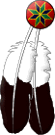
MOHAWK ONEIDA
CAYUGA ONONDAGA
SENECA
TUSCARORA
WHAT ARE LONGHOUSES?
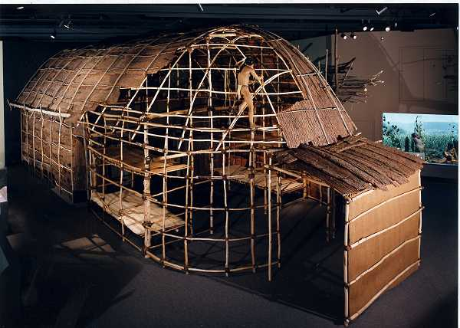
Iroquois longhouses were long, narrow homes built of wood with curved or domed shaped roofs. Some homes were as long as 200 feet and as wide as 36 feet.
Several families of the same clan lived in each longhouse, with separate compartments for each family. As many as 20 families could live in one longhouse.
The picture here is a model of a longhouse built in the Eastern Woodlands.
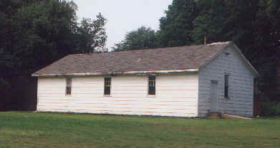
The longhouse pictured here was from the 1980s found in WNY. It was taken in Tonawanda. It is similar to what modern homes of today may look like, but still keeps it long narrow shape in its construction.

THE THREE SISTERS
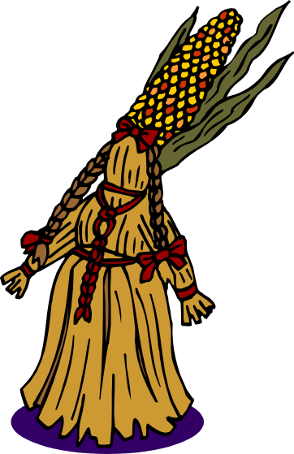

Corn, beans, and squash were planted in early summer. Seed from all three were planted in small hills. The bean vines climbed the corn stalk, and the squash grew below. By midsummer, the fields looked overgrown with weeds but were actually filled with vegetables. The Iroquois called the three crops growing together the Three Sisters.
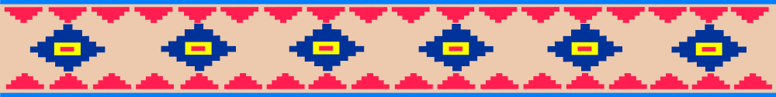
Life In The Eastern Woodlands

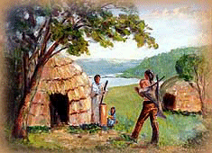
The main focus of the Iroquois Indians was meeting their basic needs. Food, Clothing, and shelter were always important goals of each village. Women, men, and children played their part within the village.
The Iroquois Nations did more farming than many other American Indian nations.

What did the men do?
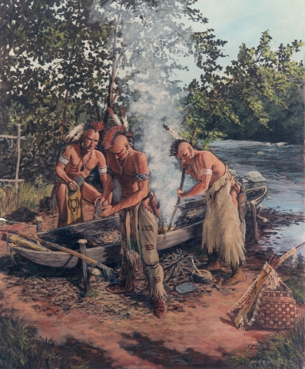
Besides being powerful warriors, the Iroquois men were skilled hunters. They hunted deer, moose, rabbit and caribou. Sometimes they would disguise themselves in animal skin to draw the animals closer.
The Iroquois men loved to fish too. They used spears, bows, and arrows to catch fish. They also carved canoes for themselves and often would go out fishing at night.
What did the women do?
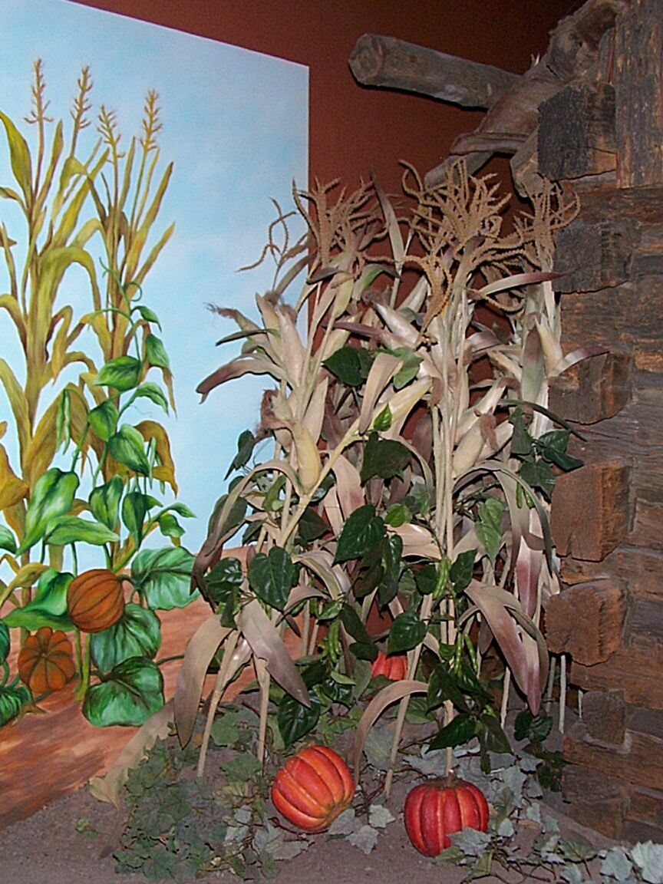
The role of the woman was very important in the Iroquois village. Although it was the man’s job to clear the field for planting, it was the women who planted and picked the crops. They were in charge of the harvest that kept the Iroquois from starving through the winter.
The women prepared all the food and made clothes with animal skin and plant fiber.

What did the children do?
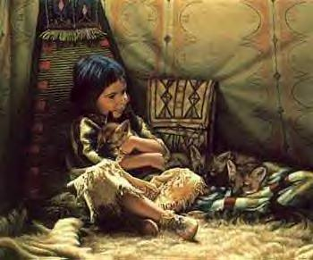
The children helped get water and wood for fire. Boys learned to shoot a bow and arrow, and to shoot, build traps for bear, deer, turkey, rabbits, and other animals. Girls learned to cook, make pottery, and make clothing.
Think of life in the Eastern Woodlands and the jobs each person had. Compare them to some jobs you may have today in your family. Would you have liked or disliked your job in the Iroquois village?

How was each village governed?
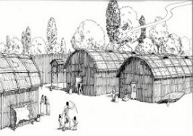
The Iroquois Nation had a unique form of a representative central government. It was called the League of Nations. The League had a written constitution, a set of rights and agreements that all the people had to honor. The constitution was recorded on 114 wampums. The League had a Council. Each Iroquois Nation had a set number of seats on the Council. The decisions of the Council were binding on every person in all Iroquois Nations. The League's primary purpose was the Great Law of Peace. This law said that the Iroquois should not kill each other.

What is a WAMPUM?
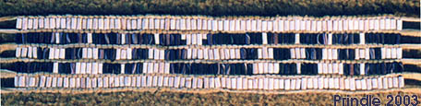

The Iroquois of the northeast region of the United States made white and purple beads called WAMPUM. They did this by cutting and drilling shells. They then sewed the beads into wampum belts, which were considered sacred to the Iroquois people. Wampum belts had woven symbols or pictures, which only certain people in the tribe knew how to read. The belts recorded agreements between the tribes.
Above is a picture of a wampum made by the Iroquois. Some of our fourth graders created their own wampum belts by weaving yarn and beads together. Many of them can tell you, it was not easy and it took a lot of time. We now appreciate all the work that went into the Iroquois wampum belts and the skill they needed to create them.
We hope you enjoy our hard work.

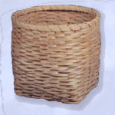
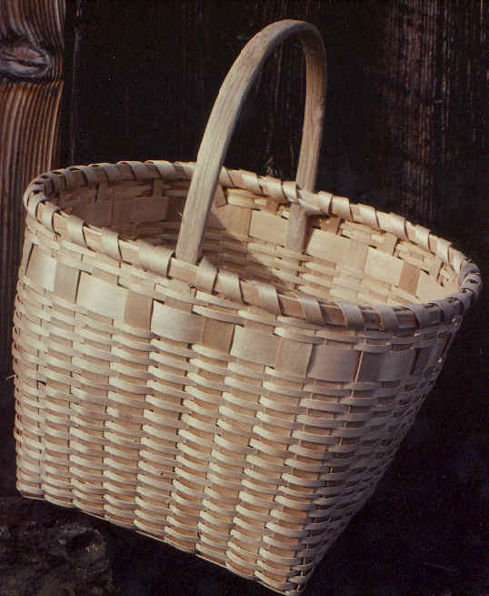
BASKET MAKING
Baskets have been made to sell or trade by the Iroquois since the late 1700s. They were and continue to be an important economic asset for the Iroquois. Originally baskets were made by Iroquois for such purposes as storage, food preparation, and transportation. Many of the first baskets made for trade were work baskets. While many of these were strictly work baskets, some of the storage baskets were ornamented with painted or stamped designs. These baskets could be sold to tourists at such places as Saratoga Springs or Niagara Falls or to trading posts.
Take a look at our weaving mats we made to demonstrate the weaving skill the Iroquois had.

Do You Know the Algonquians?
Did you know that the enemy of the Iroquois the Algonquians, were the first people to settle in New York?
The Iroquois Confederacy drove them farther east. Most Algonquians tribes were similar to the Iroquois including the organization of their villages. They too were located along the river and near other bodies of water.
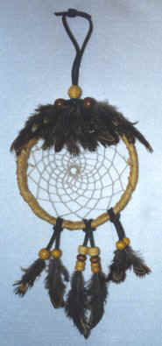
The Algonquian Indians hung dreamcatchers from cradleboards to protect their babies. They believed that the dreamcatcher would catch bad dreams and allow good dreams to pass through the web.
Here are some examples of dreamcatchers that may have been made by the Algonquian people. Think of a dream you may have for yourself. What is one good dream you would like to pass through your catcher? What is one you hope it catches?

Homes of Other Native Americans
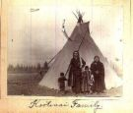
Tribes that lived in the plains followed buffalo and needed homes that were easily moved. They lived in teepees. A teepee was made from leaning poles together and covering them with buffalo hide. The few tribes that didn't move around lived in dome-shaped grass lodges.

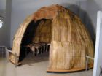
Algonquian villages had both long homes and wigwams. Wigwams were built for summer camps and hunting trips. They were made with the same materials as longhouses, but would only hold a single family. Wigwams were small enough to be taken apart and rebuilt easily, which made them perfect for temporary shelter.

STRAWBERRIES

Like the Algonquians, the Iroquois gathered ripe berries in the spring each year. The Iroquois called strawberries a food of the spirit, because they were shaped like a heart.
The leaves of the strawberries were used to cure pains. Today, strawberries are still celebrated by the Iroquois with a special ceremony.


